Smart Ambulance
Priority-Based Patient Telemetry on QNX Neutrino RTOS
Detailed Project Documentation
State Level Hackathon
Team: Dharani_aus [Surampalem]
Domain: Healthcare / Emergency Medical Services
Critical alerts never wait behind routine telemetry.

Table of Contents
1. Introduction 3
2. Problem Statement 3
3. Solution Overview 3
4. System Architecture 4
5. Triage Rules 4
6. QNX Concepts Used 5
7. Message Format and Reply Codes 5
8. Code Walkthrough 6
9. Build and Run Instructions 6
10. Test Scenario and Output Walkthrough 8
11. Resilience and Error Handling 11
12. Performance 11
13. Limitations and Known Behaviour 11
14. Future Scope 12
15. Key Learnings 12

1. Introduction
Smart Ambulance is a real-time telemetry system that streams patient vitals from an ambulance to a hospital. It is built on the QNX Neutrino RTOS using native microkernel message passing. The core guarantee is simple: a life-threatening reading is always processed before routine data, no matter how much routine traffic is already in flight.
The project consists of two programs:
Program | Role
Ambulance Transmitter | Takes patient vitals, validates them, classifies each reading as CRITICAL or ROUTINE, and sends it to the hospital.
Hospital Receiver | Receives readings on two separate channels, processes critical alerts on a high-priority thread and routine data on a low-priority thread, and acknowledges every message.

2. Problem Statement

2.1 Scenario
An ambulance continuously streams heart rate, SpO2, temperature, GPS position and emergency severity. If the hospital system is busy processing routine updates when a critical reading arrives, the alert is delayed and the ER loses valuable preparation time.

2.2 Why it matters
A late alert means late treatment. The critical alert must be handled first, every time.

2.3 Success metrics
Metric | Target
Critical alerts served before routine work | 100%
Time for a running routine job to yield after a critical alert | Within 100 ms
Interrupted routine job | Acknowledged to the sender as INTERRUPTED
Triage | Applied by the transmitter

3. Solution Overview
The design rests on three ideas:
- Triage at the source. The transmitter decides, per reading, whether it is critical or routine.
- Separate channels and threads. Critical and routine traffic use different QNX channels, each served by its own thread, so critical traffic can never queue behind routine traffic.
- Priority-based preemption. The critical thread runs at SCHED_RR priority 30 and the routine thread at priority 10. A shared, mutex-protected counter lets the long-running routine job notice a critical arrival and yield.

4. System Architecture
Ambulance Transmitter | Hospital Receiver
Reads vitals; validates ranges; classifies each reading as CRITICAL or ROUTINE | Critical channel > Critical thread (SCHED_RR 30): prints alert at once, increments critical_count, replies CRITICAL
MsgSend (critical) ------> | Routine channel > Routine thread (SCHED_RR 10): 5 s job (50 x 100 ms), aborts if critical_count changes, replies INTERRUPTED
MsgSend (routine) ------> | Shared critical_count protected by a mutex
<------ MsgReply (acts as the ACK) | Reply codes: 1 CRITICAL, 2 ROUTINE, 3 INTERRUPTED, -1 REJECTED

4.1 Design decisions
Decision | Reason
Two processes (transmitter, receiver) | Mirrors the real ambulance-to-hospital separation and uses QNX IPC between processes.
Native MsgSend / MsgReceive / MsgReply | Synchronous and priority-aware; the reply doubles as the ACK.
One channel per priority class | Critical traffic never waits behind routine traffic.
_NTO_CHF_FIXED_PRIORITY on both channels | The receiving thread keeps its own fixed priority instead of inheriting the sender priority.
SCHED_RR priorities 30 and 10 | Deterministic priority ordering of the two receiver threads.
Mutex-protected critical_count | Safe signalling from the critical thread to the routine thread.

5. Triage Rules
Triage is applied by the transmitter before sending. Critical readings go to the critical channel; everything else goes to the routine channel.
Parameter | CRITICAL if | ROUTINE
Severity (1-5) | 4 or 5 | 1 to 3
Heartbeat | < 50 or > 130 BPM | 50 to 130 BPM
SpO2 | < 90 % | 90 % or more
Temperature | > 39 C or < 35 C | 35 to 39 C (inclusive)
GPS | Never | Always

5.1 Input validation
Before triage, every reading is range-checked. A set containing any out-of-range value is discarded and the user is asked to re-enter it.
Field | Accepted range
Heartbeat | 0 - 300 BPM
SpO2 | 0 - 100 %
Temperature | 20 - 45 C
Latitude | -90 to 90
Longitude | -180 to 180
Severity | 1 - 5

6. QNX Concepts Used
Concept | Where | Purpose
ChannelCreate(_NTO_CHF_FIXED_PRIORITY) | Receiver | Creates the critical and routine channels with fixed receiver priority.
ConnectAttach(..., _NTO_SIDE_CHANNEL, ...) | Transmitter | Opens a connection to each channel using the hospital PID and channel IDs.
MsgSend | Transmitter | Sends a reading and blocks until the reply (ACK) arrives.
MsgReceive | Receiver | Blocks until a message arrives on the thread channel.
MsgReply | Receiver | Unblocks the sender and returns the reply code.
pthread_setschedparam (SCHED_RR) | Receiver | Sets thread priorities 30 and 10.
pthread_mutex_t | Receiver | Protects critical_count.
nanosleep | Receiver | 100 ms steps of the simulated routine job.

7. Message Format and Reply Codes

7.1 PatientMessage structure
typedef struct {
int ambulance_id;
int parameter; // HR, SPO2, TEMPERATURE, GPS, EMERGENCY
int priority; // CRITICAL or ROUTINE
int severity; // 1-5
double value;
double latitude;
double longitude;
} PatientMessage;

Reply code | Value | Transmitter prints
CRITICAL | 1 | ACK: Critical alert processed
ROUTINE | 2 | ACK: Routine data processed
INTERRUPTED | 3 | ACK: Routine processing interrupted
Rejected | -1 | ACK: Invalid or rejected message

8. Code Walkthrough

8.1 Ambulance Transmitter
- Setup: disables stdout buffering, then asks for the Ambulance ID, Hospital PID, Critical Channel ID and Routine Channel ID (printed by the receiver at start-up).
- Connect: calls ConnectAttach twice to obtain critical_coid and routine_coid.
- Main loop: for each patient data set it reads HR, SpO2, temperature, latitude, longitude and severity, then range-checks them.
- Critical first: severity 4 or 5 sends EMERGENCY; out-of-range HR, SpO2 or temperature each send a CRITICAL message.
- Routine next: in-range HR, SpO2 and temperature, then GPS, then EMERGENCY if severity is below 4.
- send_parameter(): builds the message, picks the connection by priority, calls MsgSend, and prints the ACK based on the reply code.

8.2 Hospital Receiver
- Creates two channels with _NTO_CHF_FIXED_PRIORITY and prints the PID and both channel IDs.
- Starts two threads: critical_receiver (priority 30) and routine_receiver (priority 10).
- Critical thread: rejects non-critical messages with -1; otherwise increments critical_count under the mutex, prints the alert, and replies CRITICAL.
- Routine thread: rejects non-routine messages with -1; otherwise records critical_count and runs a 5-second job (50 x 100 ms). After each step it checks whether critical_count changed. If so, the job aborts and replies INTERRUPTED; otherwise it replies ROUTINE.

9. Build and Run Instructions

9.1 Requirements
- QNX Neutrino RTOS (QNX SDP) target or VM
- QNX Momentics IDE or the qcc toolchain
- Privileges to set SCHED_RR priorities

9.2 Build
qcc -o hospital_receiver hospital_receiver.c
qcc -o ambulance_transmitter ambulance_transmitter.c

9.3 Run
- Start the receiver and note the printed Hospital PID, Critical Channel ID and Routine Channel ID.
- Start two transmitters in separate consoles, each with a different Ambulance ID, entering the PID and channel IDs from step 1.
- Enter patient readings in each transmitter.
Note: two transmitters are needed to demonstrate preemption. A single transmitter blocks on MsgSend until each reply returns, so it cannot send a critical alert while its own routine message is still being processed.

10. Test Scenario and Output Walkthrough
The test was run in the QNX Momentics console with three consoles side by side: the Hospital Receiver (left) and two Ambulance Transmitters (middle: Ambulance 1, right: Ambulance 2).
Hospital PID: 532501 Critical channel: 1 Routine channel: 2

10.1 Inputs
 | Ambulance 1 | Ambulance 2
Heartbeat | 96 BPM | 95 BPM
SpO2 | 95 % | 82 %
Temperature | 39 C | 36 C
Latitude / Longitude | 17 / 81 | 17 / 81
Severity | 2 | 4
Expected triage | All ROUTINE (39 C is the upper limit of the routine range) | EMERGENCY (severity 4) and SpO2 (82 < 90) are CRITICAL; the rest are routine

10.2 Step 1: Critical alerts arrive during routine processing
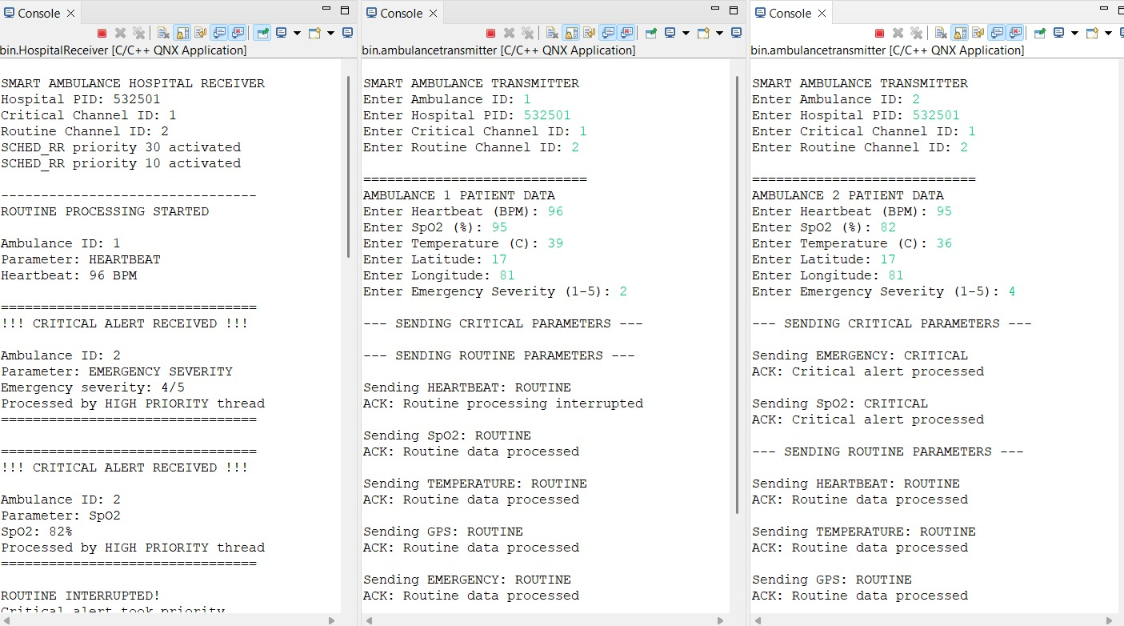
Figure 1: Critical alerts from Ambulance 2 preempt routine processing of Ambulance 1
- The receiver prints both thread priorities being activated: SCHED_RR priority 30 and 10.
- Ambulance 1 routine HEARTBEAT (96 BPM) starts processing (ROUTINE PROCESSING STARTED).
- While that job is running, Ambulance 2 critical messages arrive: first EMERGENCY SEVERITY 4/5, then SpO2 82 %. Each is printed immediately with "CRITICAL ALERT RECEIVED" and "Processed by HIGH PRIORITY thread".
- The receiver then prints "ROUTINE INTERRUPTED! Critical alert took priority."
- Ambulance 1 console shows "ACK: Routine processing interrupted". Ambulance 2 console shows "ACK: Critical alert processed" for both critical messages.

10.3 Step 2: Routine processing resumes
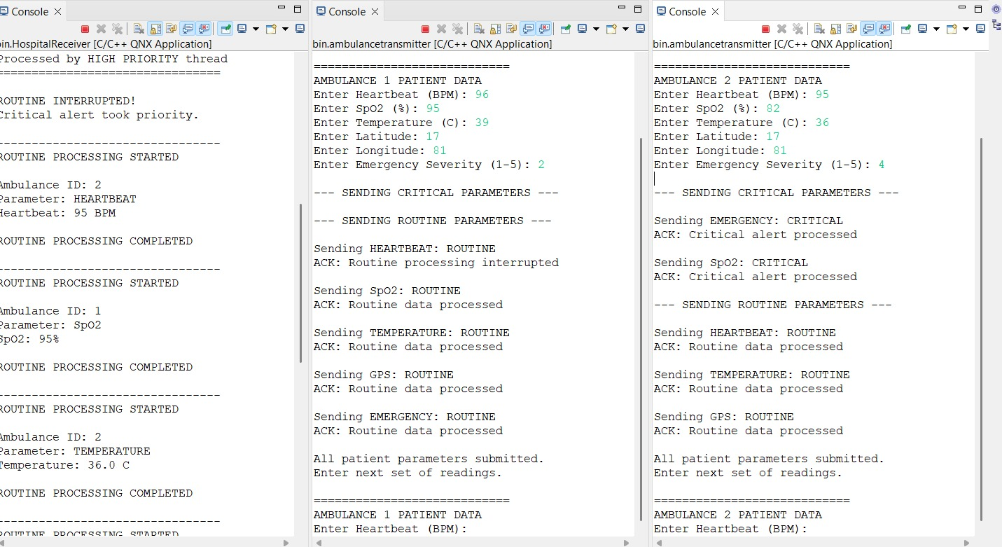
Figure 2: Interruption message, then routine processing resumes with the next messages
- The receiver moves on to the next routine messages: Ambulance 2 HEARTBEAT 95 BPM, Ambulance 1 SpO2 95 %, and Ambulance 2 TEMPERATURE 36.0 C.
- Each prints ROUTINE PROCESSING STARTED followed by ROUTINE PROCESSING COMPLETED, since no new critical alert interrupted them.

10.4 Step 3: Remaining routine data is processed
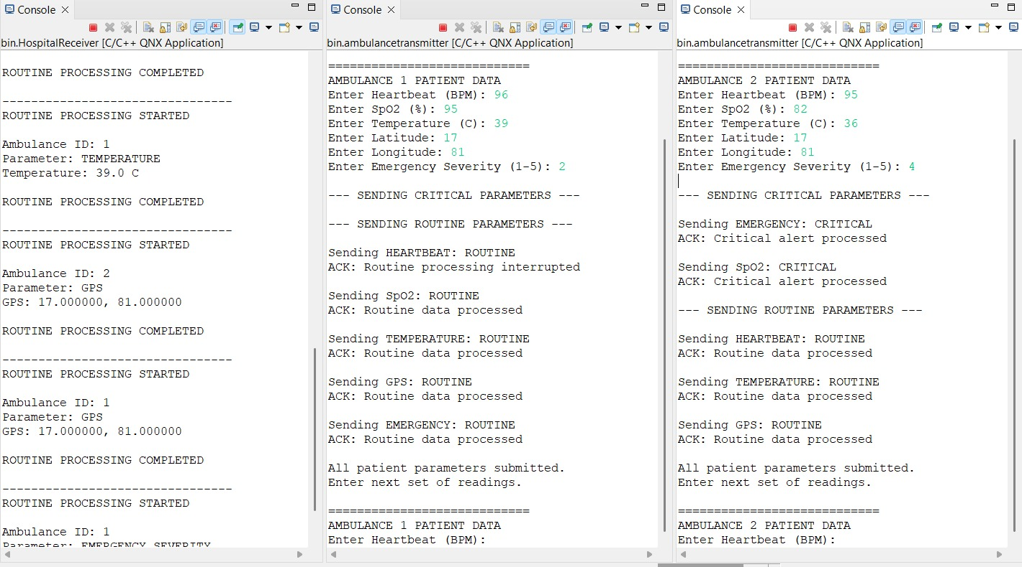
Figure 3: Routine messages from both ambulances are processed in turn
- Ambulance 1 TEMPERATURE 39.0 C, Ambulance 2 GPS (17.000000, 81.000000), Ambulance 1 GPS and Ambulance 1 EMERGENCY SEVERITY (routine) are processed in turn, interleaved between the two ambulances.

10.5 Step 4: All parameters submitted
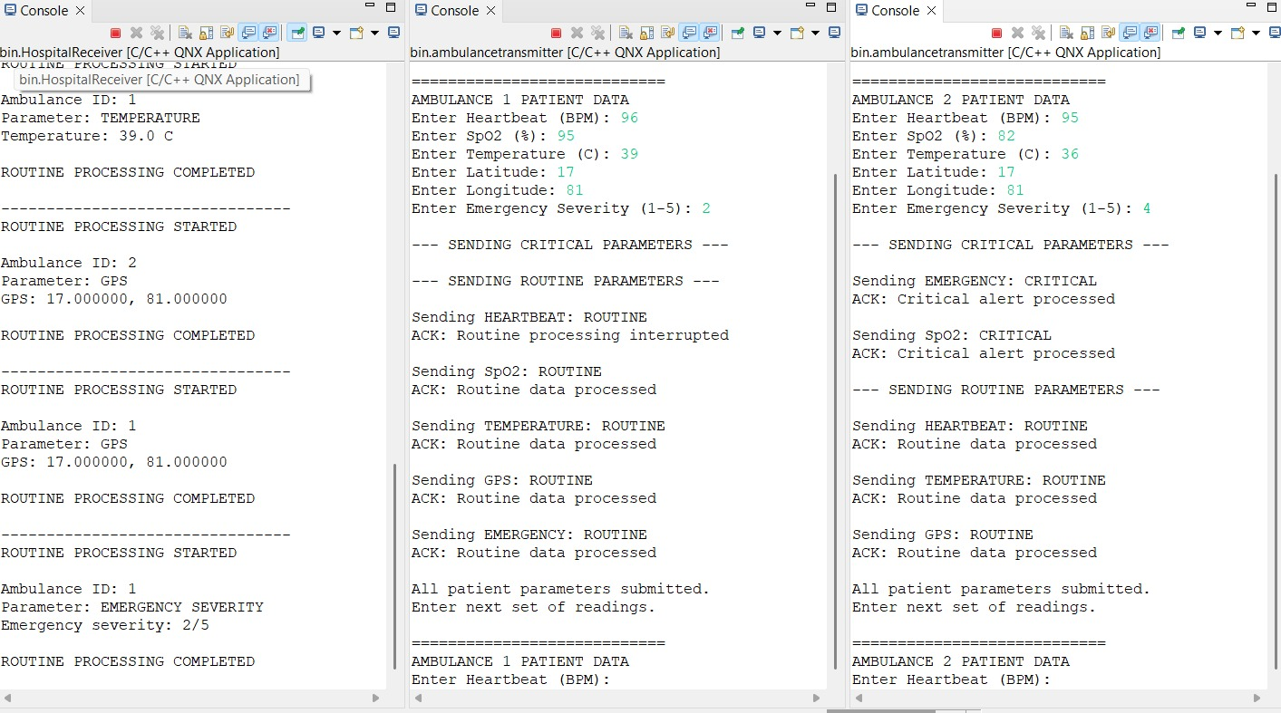
Figure 4: Final routine message completes and both transmitters are ready for new readings
- The last routine message (Ambulance 1, Emergency severity 2/5) completes with ROUTINE PROCESSING COMPLETED.
- Both transmitters print "All patient parameters submitted." followed by "Enter next set of readings."

10.6 What the output proves
Observation | What it shows
Critical alerts print immediately while a routine job is running | The high-priority thread preempts routine work.
ROUTINE INTERRUPTED followed by ACK: Routine processing interrupted | The routine job detects the critical arrival and yields; the sender is informed.
Ambulance 2 critical messages served before remaining routine messages | Order is decided by priority, not arrival time.
Both ambulances served interleaved | The receiver handles multiple ambulances at once.
Undisturbed routine messages complete normally | Normal operation is unaffected.

11. Resilience and Error Handling
Risk | Mitigation
Critical alert arrives during a 5 s routine job | Dedicated high-priority thread and channel; the routine job polls every 100 ms and aborts, replying INTERRUPTED.
Several ambulances transmit at once | Each message carries an ambulance_id; the critical channel is served by the high-priority thread regardless of sender.
Invalid readings | Transmitter range-checks every reading and discards bad data sets.
Message sent on the wrong channel | Receiver replies -1; transmitter prints "Invalid or rejected message".
MsgReceive / MsgSend failure | Errors are reported with perror; the receiver loops and the transmitter returns from the send.
Insufficient scheduling privileges | Receiver prints a clear message and exits if pthread_setschedparam fails.
Concurrent access to critical_count | Protected by a mutex.

12. Performance
Metric | Value
Critical thread priority (SCHED_RR) | 30
Routine thread priority (SCHED_RR) | 10
Routine job length | 50 x 100 ms = 5 s
Maximum time for routine work to yield (design) | 100 ms (one polling step)
Measured critical alert latency | To be filled from the QNX Momentics System Profiler

13. Limitations and Known Behaviour
- Interrupted routine messages are not retried. The receiver acknowledges them as INTERRUPTED and moves on. In the test above, the Ambulance 1 HEARTBEAT reading was dropped this way; the transmitter is informed through the ACK but does not resend it.
- Console input only. No GPIO or real sensors in this build.
- Polling, not events. Interruption is detected by checking a counter every 100 ms.
- Simulated routine work. The 5-second routine job is a simulated delay.
- Single routine thread. Routine messages from all ambulances are processed one at a time.
- No CPU sets or affinity, and a plain mutex rather than a priority-inheritance mutex.

14. Future Scope
Area | Idea
Real sensors | Pulse-oximeter, temperature sensor and GPS over UART or CAN replace console input.
Network scale | Send the same messages over QNX Qnet to a remote hospital node, with many ambulances.
Event-driven design | Replace 100 ms polling with an event or pulse for faster interruption.
Safety hardening | Priority-inheritance mutex, HAM auto-restart, CPU affinity, logging.
Reliability | Retry or re-queue interrupted routine messages.

15. Key Learnings
- A blocking MsgReceive server cannot be interrupted mid-job.
- The fix is priority-separated channels and threads.
- A mutex-protected counter, polled every 100 ms, lets the low-priority job yield to critical work.
- Priority, not arrival order, should decide what gets processed first in safety-critical systems.
Every second counts: the right alert reaches the ER first, every time.

